**System Information**

There are various commands in linux to retrieve details about the hardware, operating system and other relevant information. Here are some commonly used commands:-

1. **uname -a**

**‘uname -a’** command is used for to displays the detailed system information including the kernel version, hostname, release, architecture etc.

In this output from the ‘uname-a’ command it provides various details about the linux system . Here’s the detailed information:-

1. **Kernel version:** 6.5.0-kali3-amd64
2. **Hostname:** suman
3. **Kernel Release Date:** Debian 6.5.6-1kali1 (2023-10-09)
4. **Architecture:** x86_64
5. **GNU/Linux:** GNU project and uses linux kernel.
6. **lsb_release -a**

**‘lsb_release -a’** command provides information about the Linux distribution and

version.

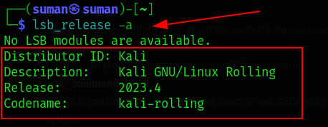

1. **hostname  
   ‘hostname’** command display the name of the host system.

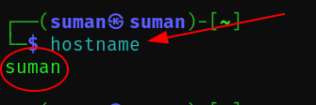

1. **Cat /etc/os-release**This commands shows the information from the ‘/etc/os-release’ file, including the distribution name, version, and ID.

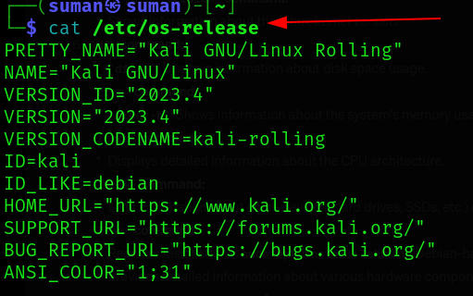

1. **df -h**

This command is used to display the information about disk space usage on linux

system.

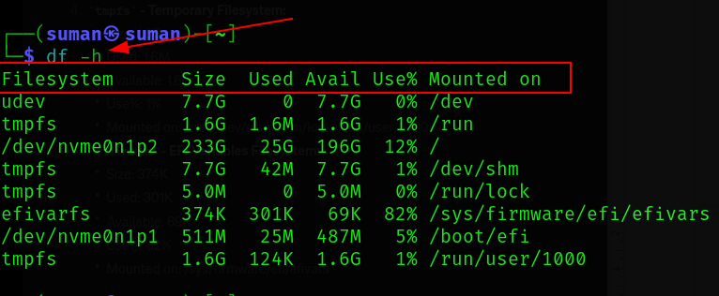

Here’s the more information of this output:-

* Filesystem : Indicates the name of the file system.
* Size : Represents the total size of the file system.
* Used : Displays the amount of disk space used.
* Avail : Shows the available(free) disk space.
* Use% : Indicates the percentage of disk space used.
* Mounted on : The directory where the file system is mounted.

1. **Free**

**‘free’** command nis used to get information system’s memory usage.

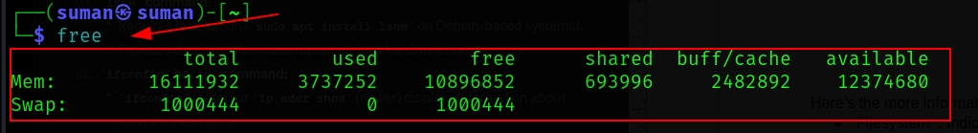

Here’s the detailed information about the output (system’s memory usage):-

* total : total RAM available in the system in this case, it’s 16,111,932kb
* Used : amount of ram currently in use. IN this case it’s 3,737,252 kb
* free : amount of free ram . In this case it’s 10,896,852 kb
* shared : used memory can be shared among multiple processes. In this case it’s 693,996 kb
* buff/cache : memory used for file system buffers and cache. In this case, it’s 2,482,892 kb
* available : an estimate of how much memory is available for starting new applications, without swapping. In this case, its’s 12,374.680 kb.

1. **lsblk**

This command is used to list information about block devices(hard drives, SSDs, etc.) on the system.

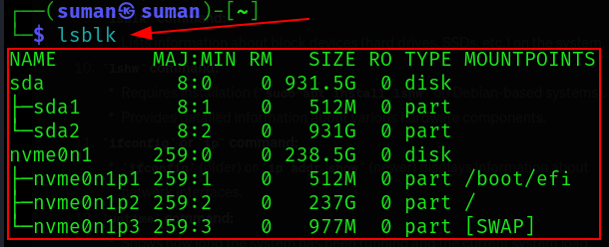

Here’s the breakdown of the output:-

* sda:
* A disk with a total size of 931.5 GB
* Contains tow partitions:
* sda1: 512 MB in size.
* sda2: 931 GB in size.
* nvme0n1:
* Another disk with a total size, mounted at ‘/boot/efi’.
* Contains three partitions:
* **nvme0n1p1** : 512 MB in size, mounted at ‘/boot/efi’.
* **nvme0n1p2:** 237 GB in size, mounted at /.
* **nvme0n1p3:** 977 MB in size, used as swap space.

1. **uptime**

The ‘uptime’ command provides information about how long the system has been running .

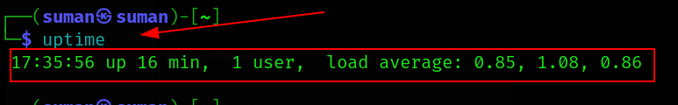Here’ the breakdown of this output:-

* **17:35:56:** The current time.
* **up 16 min:** The system has been up and running for 16 minutes.
* **1 user:** There is currently 1 user logged into the system.
* **load average: 0.85, 1.08, 0.86:** The system load averages for the last 1, 5, and 15 minutes, respectively.